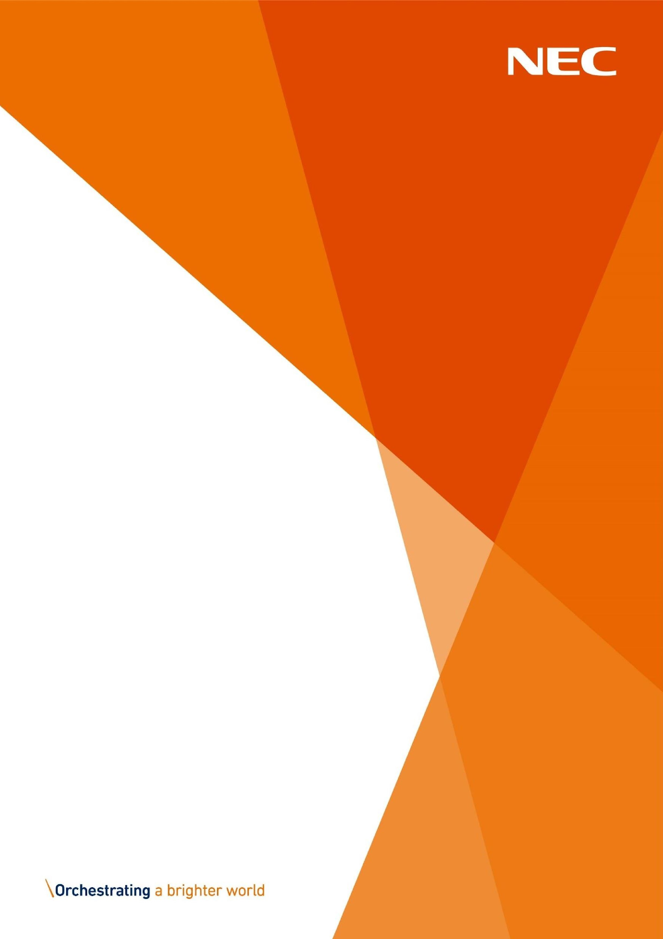
Discretionary Assistance
Fund (DAF) Approved
Partner Bulletin

April

2026
NECSWS.COM

Further Update

We are happy to announce that from 1st April 2026 50cm and 60cm electric cookers will now be available for our applicants experiencing a crisis.

Any queries regarding this please contact Charlotte Perry Partnership and Engagement Manager @ DAF.Partners@necsws.com.


Approved Partner Bulletin



