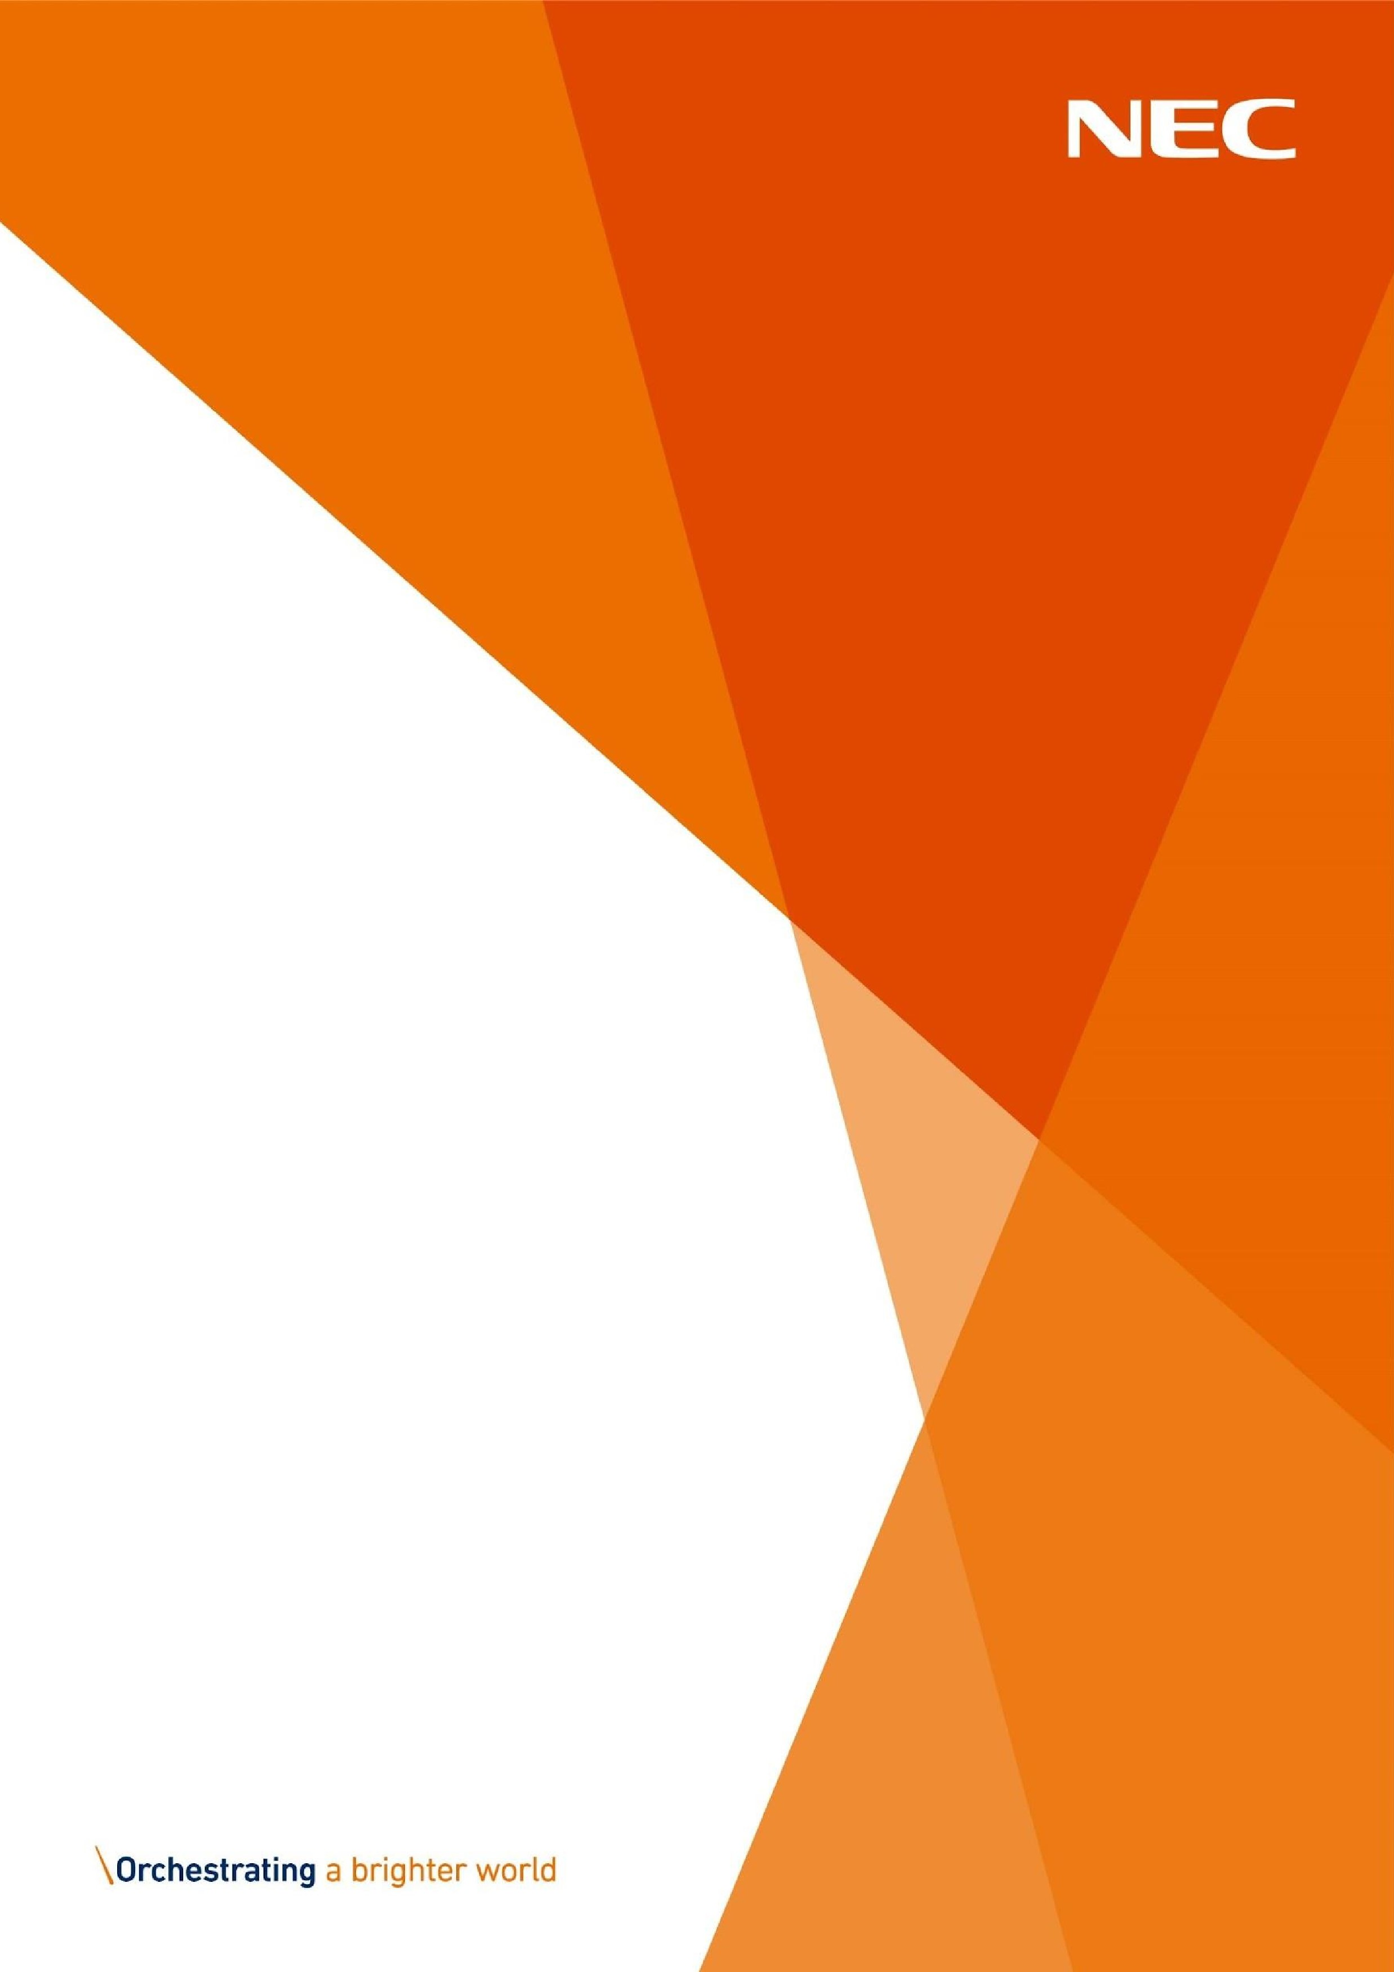
Discretionary Assistance
Fund (DAF) Approved
Partner Bulletin

January

2026
NECSWS.COM

Partner Network
- “Hold the Date” for the DAF Q & A event.
9th February 11am - 12:30 pm. Main contact for all Approved Partners will receive a formal invitation early January.

- We are looking for Approved Partners that would be willing to give us an impact statement on how DAF supports the work your organisation is undertaking, and the people you directly support. What would have been the outcome if DAF was not available? If you are able to spare 10 minutes to put your thoughts to email, please drop the Partnership Manager an email at DAF.Partner@necsws.com.

Updates

- EAP payments will be increased by 8.1% from 1st January 2026. The new rates are as follows:
1 person household £61
2 person household £72
3+ person household £120

- An individual with shared childcare arrangements but not in receipt of Child Benefit, will now be able to claim a 2+ household level of EAP even if they are a 1 person household when not undertaking child care.

- A first time EAP application for a person who is fleeing domestic abuse can now receive an Enhanced payment of £111 if supported by an Approved Partner.

- An applicant fleeing domestic abuse is now able to apply for an IAP if they are NOT in receipt of a Means Tested Benefit. In addition to this they cannot have any savings and we require our Approved Partners to verify they do not have any savings. This is in line with the current rules for those who do receive a means tested benefit, we cannot approve an IAP where the person has any savings.

- To receive one of our exceptional items (flooring grant/heated air dryer) in addition to Enhanced rate mobility PIP/DLA, Attendance Allowance is now also part of the criteria. The applicant must also have a medical need that directly links to the item.

- We are happy to announce that BAC’s is now available for payments under £100. Applicants are still able to receive a PayPoint voucher if under £100. Applications will ask which way the client would like to be paid.

Reminders

- Please ensure that full and correct addresses are provided on all applications. Errors in the address can cause delays in IAP items being delivered to our applicants in crisis.

- The DAF scheme does not cover broken items, if there are extenuating circumstances which you believe warrants this help, please contact the Partnership Manager, after the application has been placed.

- Yearly refresher training is mandatory for all Approved partners; your partner code may be revoked if this training is not undertaken.

- Please ensure that your clients are home for the delivery slot they have been allocated. There is a limit on the delivery attempts we can make, once these are exhausted a new application will need to be made.
We ask that your clients allow the delivery agents into their homes. Items including beds and cots will be built by the delivery agents and washing machines will be plumbed in. All packaging will be removed by the delivery agents.

- Please be reminded that there is a limit of 3 applications in a rolling 12-month period, there are NO exceptions to this rule.

- The Discretionary Assistance Fund (DAF) in Wales provides financial support to citizens facing an unexpected financial crisis or emergency. However, it does not offer cash payments for ongoing bills or circumstances for which a claim has previously been made. This fund is designed to assist individuals during unexpected and severe hardships beyond the challenges of a low income. If your organisation requires any refresher training regarding this then please contact the Partnership and Engagement Manager at daf.partners@necsws.com.

- The role of the registered DAF partner is to undertake verification checks on individuals and eligible benefits before submitting the application. If this information is incorrectly entered or missing, the application will be delayed or refusal.

- It is highly important that your Partner Code is not read out in front of your clients, nor shared with anyone outside of you partner organisation. Breaches of the code will result in the code being revoked. Depending on the circumstances, temporary and in some instances on a permanent basis.

- Our cooking bundles are made up of a slow cooker, air fryer, microwave and hot plate. You are not required to have all 4 items and only need to select what the people you are supporting require. To note – you can only choose either the cooking bundle OR the counter top cooker with hob – not both.

For all DAF related feedback or queries please contact us at DAF.Partners@necsws.com.

Charlotte Perry Partnership and Engagement Manager


Approved Partner Bulletin



